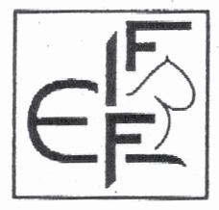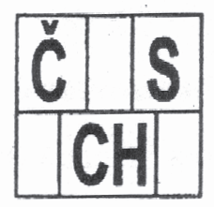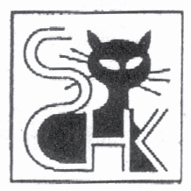

ZO CHUK Usti nad Labem II would like to invite you to

18th and 19th FIFe INTERNATIONAL CAT SHOW (Two Certificates)

USTI NAD LABEM (North Bohemia) - 16th – 17th JULY 2011

at DUM KULTURY (Cultural Hall) GPS 50°39'45.31"N 14°2'21.82"E
Velka Hradebni 19/1025, Usti nad Labem (City Centre)

Invited judges: Mrs.Hanne-Sofie Sneum (DK) I-IV, Mrs.Ulrike Wahl (DK) II, MVDr.Květa Mahelková (CZ) I-IV, p.Berta Němcová (CZ) I-IV, Mr.Luigi Comorio (IT) I-IV, Mr.Rolf Vöhringer (CH) I-IV
changes of judges are possible

Deadline for the entries: 8th July 2011 Cancellations accepted only by this date.

Postal address for entries: completely filled (readably), confirmed by the own organisation please send on the address: Mrs.Vladimíra Reinhartova, Vita Nejedleho 971, Lovosice, 410 02, Czech Republic, E-mail address for entries: vystavamvkul@seznam.cz, Fax. No: +0420 416 59 73 69. The exhibitors of cats in category II and III, which are judged in group by colour, must write the colour-group on the entry form! If the exhibitors write an e-mail address, they will receive proof of entry or unacceptance by e-mail. Should you not receive this, please contact the organisation by e-mail.
Mobile Phones available:
+0420 602 361 362 (entries) – available at the period 1.6. - 31.7.2011 (person speaks limited English, so better to send e.mail to: vystavamvkul@seznam.cz)
+0420 721 203 396 (hotel booking, general questions)

All foreign entries may pay entry fee on arrival !

1 Day 2 Days
Entries: Class 1,3,5,7,9, EUR 30 EUR 55
Class 2,4,6,8,10,11,12,17 EUR 25 EUR 45
Class 13,14,15,18 EUR 18 EUR 33
Class 16 (min. 3 kittens) EUR 35 EUR 65
Extra charge for double cage for one cat
(except Class 16, limited spaces) EUR 20 EUR 40

Advertising in the Show Catalogue: Full A5 page EUR 15
Half A5 page EUR 10

The show program:
Saturday Sunday
7,00 – 9,00 entrance and veterinary check-in 7,00 – 8,30 entrance and vet.check-in
9,00 – 9,30 corrections, control class 8,30 – 9,00 corrections, control class
9,30 – 15,30 judging and nominations 9,00 – 14,30 judging and nominations
15,30 – 17,30 BIS 14,30 – 16,30 BIS
17,30 closing of show 16,30 closing of show
If necessary, changes in the programme are possible.

The cat show is organised according to FIFe rules. Exhibitors may present their cats to the judges themselves, stewards will be available. Participation is at risk of the exhibitor.

Show cages: will be presented according surnames of exhibitors, e.a. the exhibitor will have all his cats together. Movements of cages is strictly FORBIDDEN !

Veterinary rules: All exhibitors must provide a veterinary certificate showing a valid cat vaccination against panleukopenia, respiratory disease and rabies. White cats must have vet confirmation that they are not deaf. The cats must have their nails cut.

Hotel Accommodation: We can provide special discounted prices for your accommodation at INTERHOTEL BOHEMIA (3 minutes from Show Hall). Please contact Olga Griffiths for your booking at the address: vystavamvkul@seznam.cz

Warning:
Registrations and cancellations will not be accepted after closing date.
If you will leave the show earlier without permission, the cat´s result will be anullated.
The participation at the show is at one´s own risk. The exhibitors can present their cats to the
judge themselves, the stewards will be available as well. The protests against the exhibiting
rules or conditions can be given in written form with the fee 10 € during the show. In the case
of the wrongful protest the fee fall through the show´s benefit. The changes of class you can
report to the show council till 9.00 o´clock at the latest. The apologies of the animals will be
recieved only from the person, who has the animal apply for.

We are looking forward to meet you!

The council of the show

